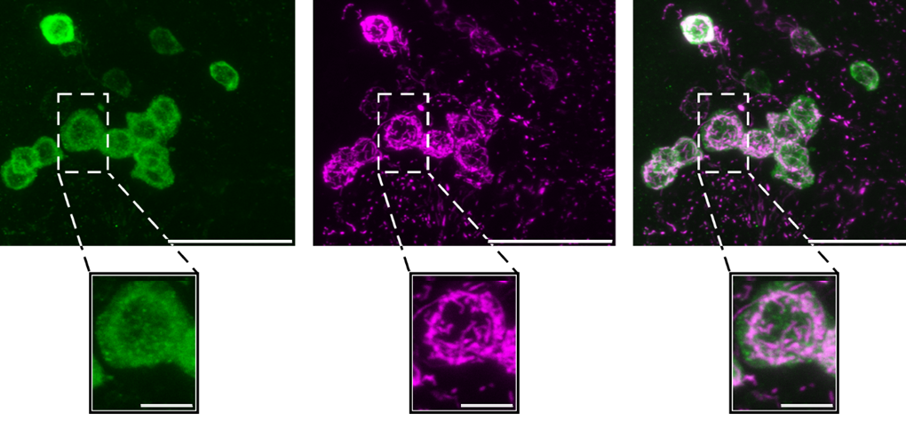

Ph.D. project “Mitochondria function in learning and memory using *Drosophila melanogaster* as a model system”

The Department of Biology at University of Köln invites applications for a Ph.D. position in the group Professor Dr. Henrike Scholz.

About the lab:

The Scholz lab has made significant contributions to the fields of addictive behaviors using *Drosophila melanogaster* as a genetic model system. Ongoing projects include functional neuroanatomy, behavior, and cellular mechanisms underlying neuronal plasticity.

Profile:  
Master’s degree in neuroscience, biology, or related field and experience in molecular genetics, biochemistry, cellular imaging, neuroanatomy or quantitative animal behavior. We are looking for a highly motivated individual with strong quantitative and technical skills and a strong interest in learning and memory. Experiences with the *Drosophila* model system, imaging techniques, behavioral analysis and neuroanatomy is desired.

The overall aim of the study is to understand the contribution of mitochondria function to the regulation of synaptic plasticity which underlies learning and memory. We have previously shown that mitochondrial transport in dopaminergic neurons is important for mediating the positive reinforcing properties of ethanol (Knabbe et al., 2022). We now want to know which aspect of mitochondria function regulates other types of learning and memory. Experiments cover a wide spectrum of behavioral analysis as well as neuroanatomical, molecular and imaging techniques.

We offer:

* Opportunity to do cutting edge science in a supportive and collaborative team.
* Working contract for 36 months
* Opportunity to perform a PhD thesis
* Membership in the graduate school of biological science offering support and soft skill courses

How to apply?   
Applicants should submit their application with a CV, a cover letter reporting any relevant experience and your motivation, a copy of the certificate of the Master’s degree and the names of two potential referees in a PDF file to **henrike.scholz@uni-koeln.de**. https://zoologie.uni-koeln.de/en/research-groups/scholz-group

The position is open until filled and applications are reviewed on an ongoing basis. However, to be fully considered, please apply by February **14, 2025**. The position is paid in accordance with TV-L 13 (65%).